**VM Record**

**1934012**

**1934036**

**1934044**

**Exercise 1 Installing Orcale VirtualBox**

**Steps:**

1. Go to <https://www.virtualbox.org/wiki/Downloads> to download Oracle virtual box.

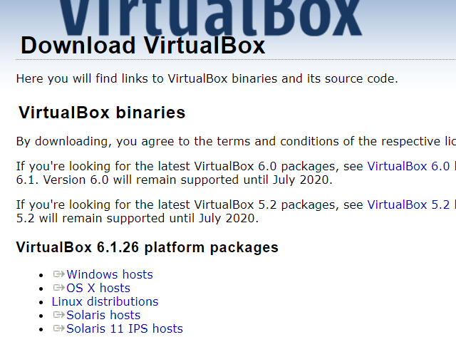

Select your OS

1. Run the file
2. Click Next

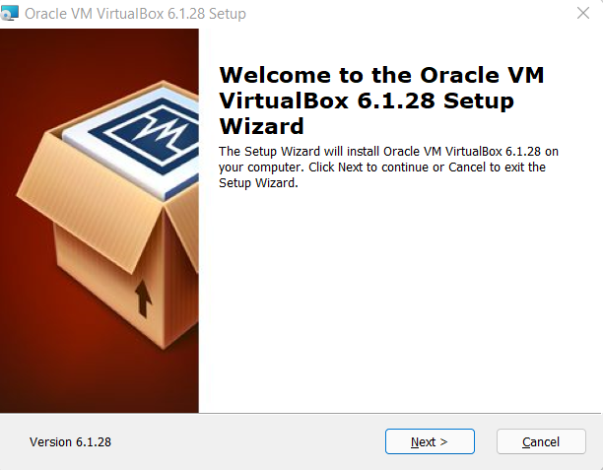

1. Leave the default settings and click next to install

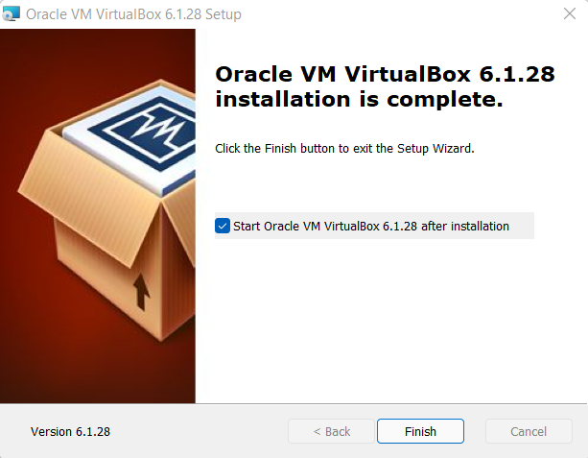

**Running a C program on Virtual Machine**

**Linux**

1. Open text editor in Ubuntu VM.

2. Write the helloworld.c Program

#include <stdio.h>

void main()

{

printf("Hello World!");

}

3. Save the file.

4. Compile the file using “gcc -o HelloWorld HelloWorld.c”

5. To run the file Type “./HelloWorld”

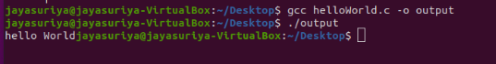

**Windows**

1. Download MinGW GCC Compiler from <https://sourceforge.net/projects/mingw/>

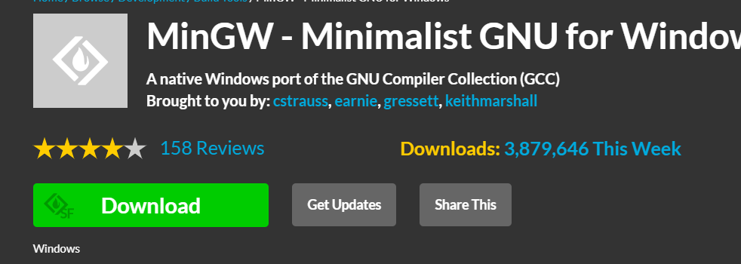

2. Install C compiler from MinGW

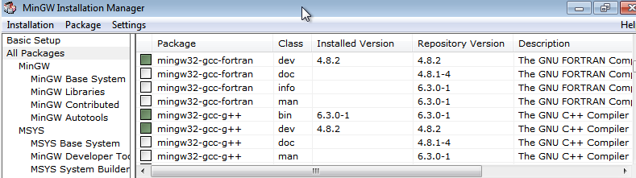

3. In a Text Editor Write the same

HelloWorld.c Program

4. In Command Prompt type “gcc -o HelloWorld HelloWorld.c” to compile the program

5. To run the program type “HelloWorld” in Command prompt

**Communication Between Host and Virtual Machine:**

1. Change the adapter Settings to Host only Adapter

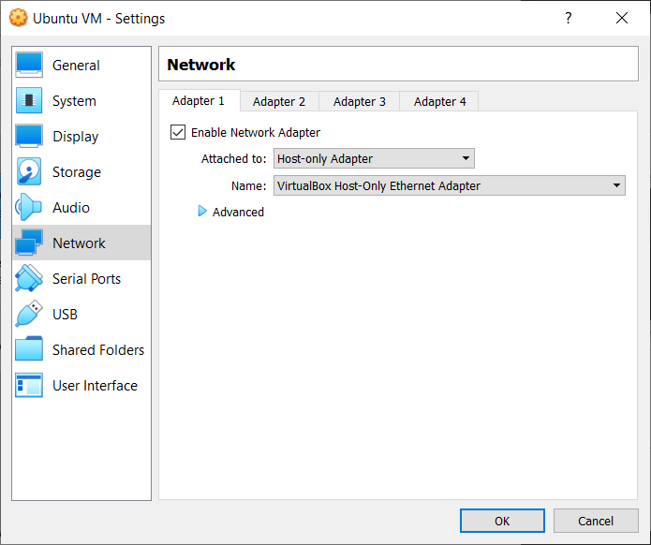

2. Ping the Guest VM from host

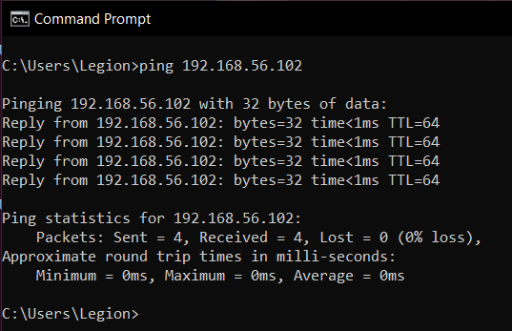

3. Install XAMPP and change the required files

4. Start XAMPP and Create a Database and a Table

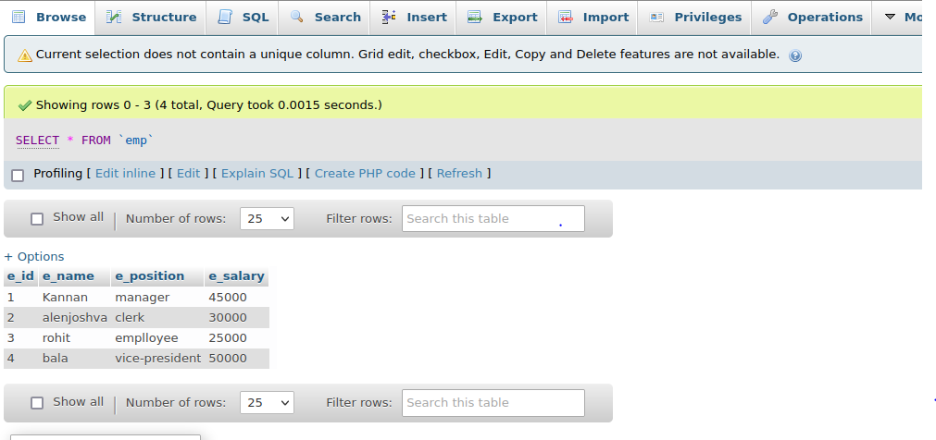

5. Create new user with IP as % or the IP of guest OS found using ifconfig.

IP

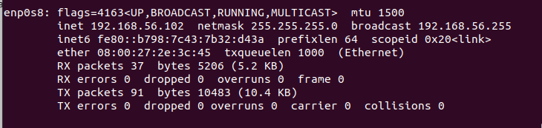

User

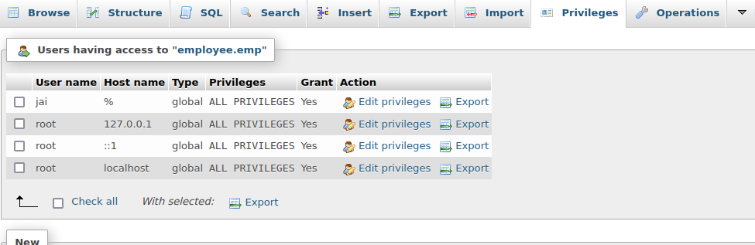

6.Download mysql-connector jar file and add to project path in Host.

7. Write a Java program to access the database in Guest OS.

import java.sql.Connection;

import java.sql.DriverManager;

import java.sql.ResultSet;

import java.sql.SQLException;

import java.sql.Statement;

public class HostVMconnection {

static final String JDBC_DRIVER = "com.mysql.cj.jdbc.Driver";

static final String DB_URL = "jdbc:mysql://192.168.56.102:3306/employee";

static final String USER = "kishore_test";

static final String PASSWORD = "password";

public static void main(String[] args) {

Connection conn = null;

Statement stmt = null;

try {

Class.forName(JDBC_DRIVER);

System.out.println("Connecting to a selected database...");

conn = DriverManager.getConnection(DB_URL, USER, PASSWORD);

System.out.println("Connected database successfully...");

System.out.println("Connecting statement");

stmt = conn.createStatement();

System.out.println("Id\tName\tDept\tRole\tSalary");

String sql = "SELECT Emp_Id,Emp_Name,Emp_Dept,Emp_Role,Emp_Salary FROM Employee";

ResultSet rs = stmt.executeQuery(sql);

while(rs.next()) {

int id = rs.getInt("Emp_Id");

String name = rs.getString("Emp_Name");

String dept = rs.getString("Emp_Dept");

String role = rs.getString("Emp_Role");

int salary = rs.getInt("Emp_Salary");

System.out.println(id + "\t" + name + "\t" + dept + "\t" + role + "\t" + salary);

}

rs.close();

}

catch(SQLException se) {

se.printStackTrace();

}catch(Exception e) {

e.printStackTrace();

}finally {

try {

if(stmt!=null)

conn.close();

}catch(SQLException se) {

}

}try {

if(conn!=null)

conn.close();

}catch(SQLException se) {

se.printStackTrace();

}

}

}

8. Run the program and Verify the result

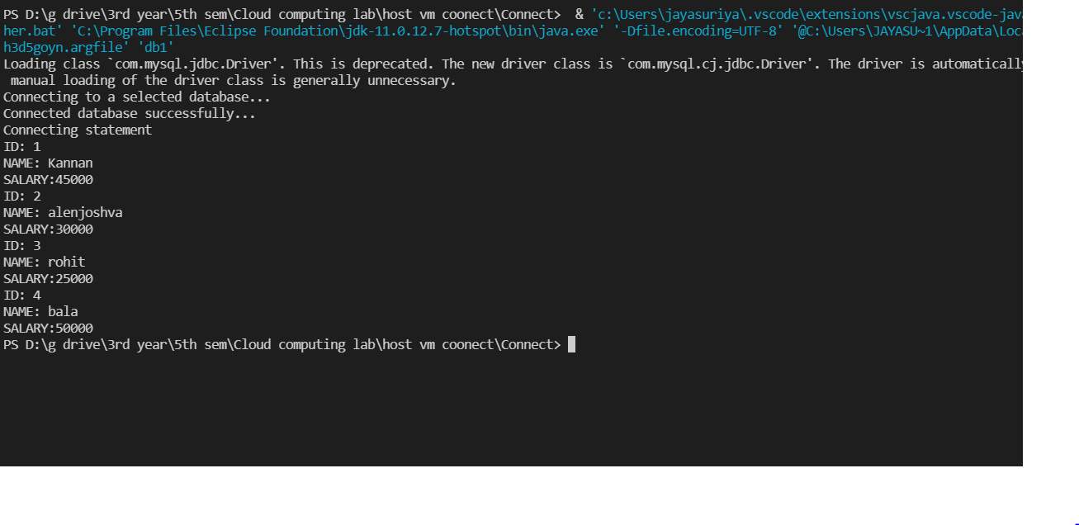

**VM to VM Connection**

1. After installing two VMs, change their network settings to BridgedAdapter

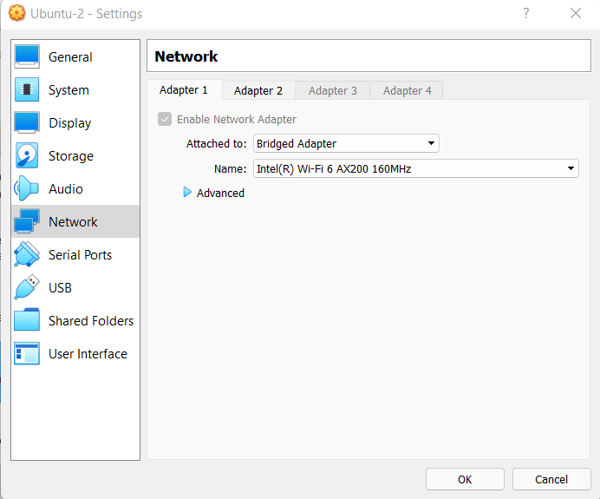

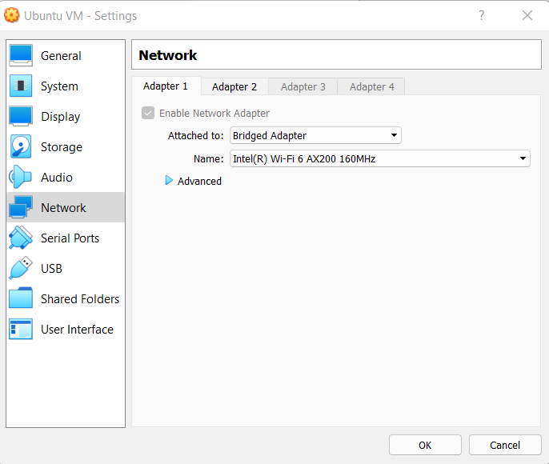

2. Ping and verify both are able to communicate with each other.

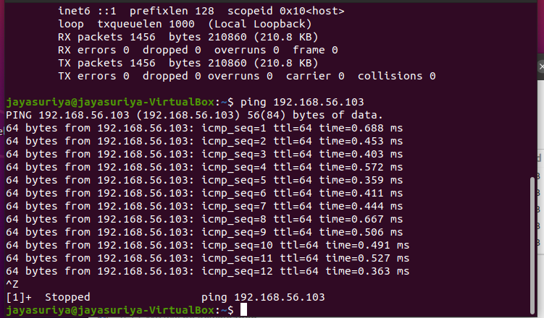

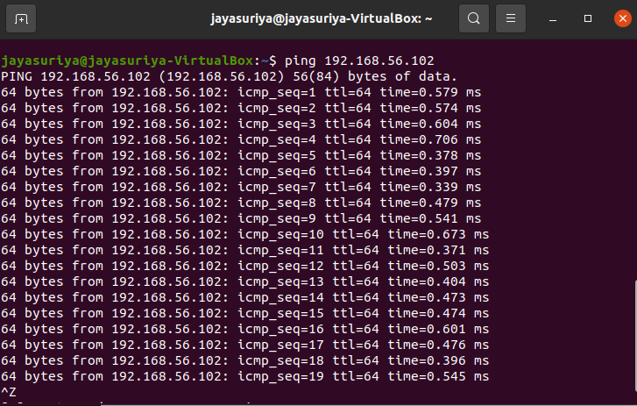

3. Install Java in the VM-B (From which we are going to access the database).

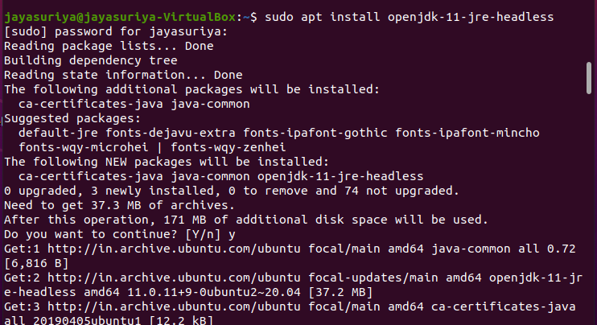

4. Install a code editor/IDE in the VM-B like VisualStudio Code or Eclipse

5. Download XAMPP package in the VM-A (Where we are going to create the Database and Table).

6. Edit my.cnf file and start XAMPP

7. Create a Database and Table using phpmyadmin

8. Insert records into the table

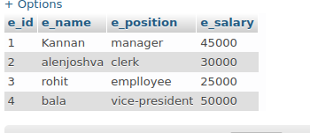

9. In both the VMs change the second network adapter to Host-only-adapter

10. Create a user in the phpmyadmin with IP either as “%” or the IP of the VM-B

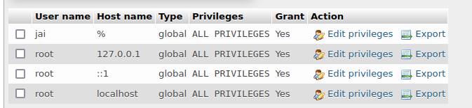

11. Download the mysql-connector-java and add it to the project path where the code is present in VM-B

12. Write the Java program in VM-B to access the databse from VM-A

import java.sql.Connection;

import java.sql.DriverManager;

import java.sql.ResultSet;

import java.sql.SQLException;

import java.sql.Statement;

public class vm_to_vm {

static final String JDBC_DRIVER = "com.mysql.cj.jdbc.Driver";

static final String DB_URL = "jdbc:mysql://192.168.56.103:3306/Employee";

static final String USER = "jai";

static final String PASSWORD = "352002";

public static void main(String[] args) {

Connection conn = null;

Statement stmt = null;

try {

Class.forName(JDBC_DRIVER);

System.out.println("Connecting to a selected database...");

conn = DriverManager.getConnection(DB_URL, USER, PASSWORD);

System.out.println("Connected database successfully...");

System.out.println("Connecting statement");

stmt = conn.createStatement();

String sql = "SELECT e_id,e_name,e_position,e_salary FROM emp";

ResultSet rs = stmt.executeQuery(sql);

while(rs.next()) {

int id = rs.getInt("e_id");

String name = rs.getString("e_name");

String role = rs.getString("e_position");

int salary = rs.getInt("e_salary");

System.out.println("ID: "+id);

System.out.println("NAME: "+name);

System.out.println("SALARY:"+role);

System.out.println("SALARY:"+salary);

}

rs.close();

}

catch(SQLException se) {

se.printStackTrace();

}catch(Exception e) {

e.printStackTrace();

}finally {

try {

if(stmt!=null)

conn.close();

}catch(SQLException se) {

}

}try {

if(conn!=null)

conn.close();

}catch(SQLException se) {

se.printStackTrace();

}

}

}

13. Run the program to see the results

to compile and run:

javac -cp /home*/*jayasuriya/Downloads/mysqlconnector-java-8.0.27/mysql-connector-java-8.0.27.jar vm_to_vm.java

java -cp /home*/*jayasuriya/Downloads/mysqlconnector-java-8.0.27/mysql-connector-java-8.0.27.jar:. vm_to_vm

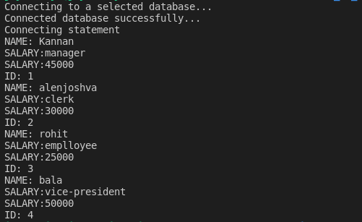

**Exporting VirtualBox VM**

1. Open VirtualBox
2. Click on File --> Export Appliance

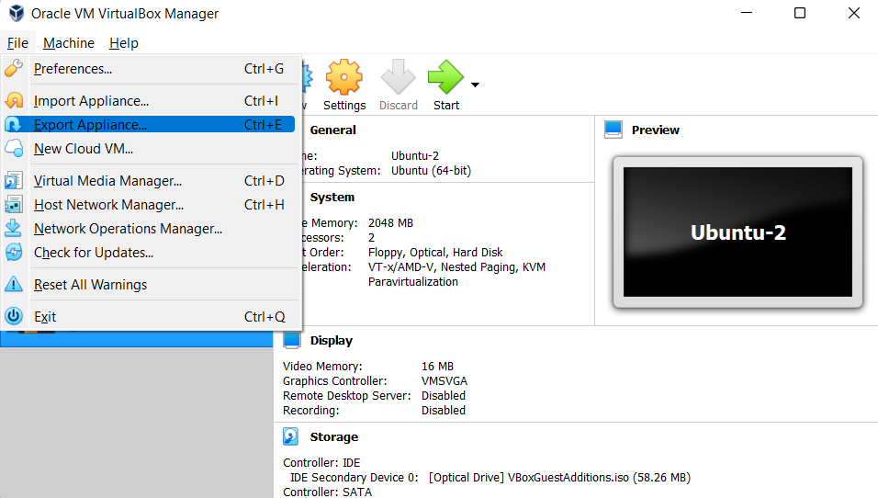

3. Select the VM you want to export

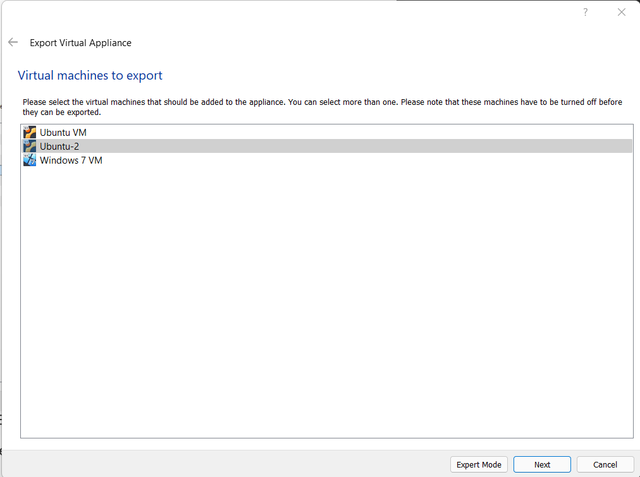

4. Select Location to store the exported VM and click Next

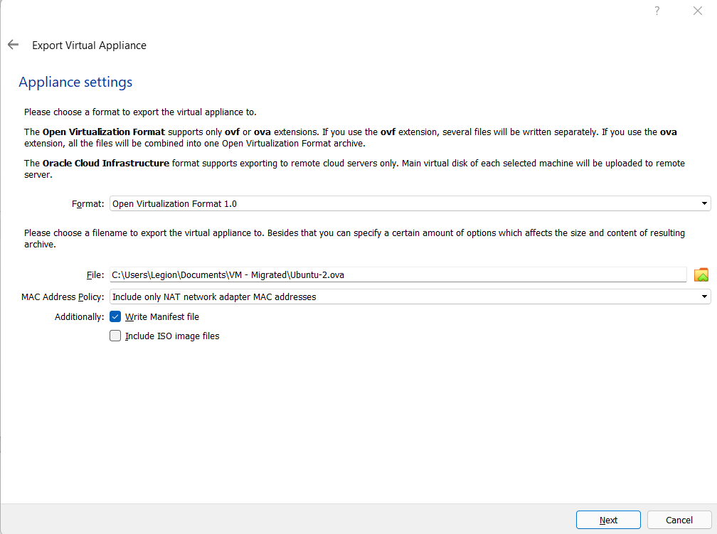

5. Add Description if wanted and click export to store the file in the location specified

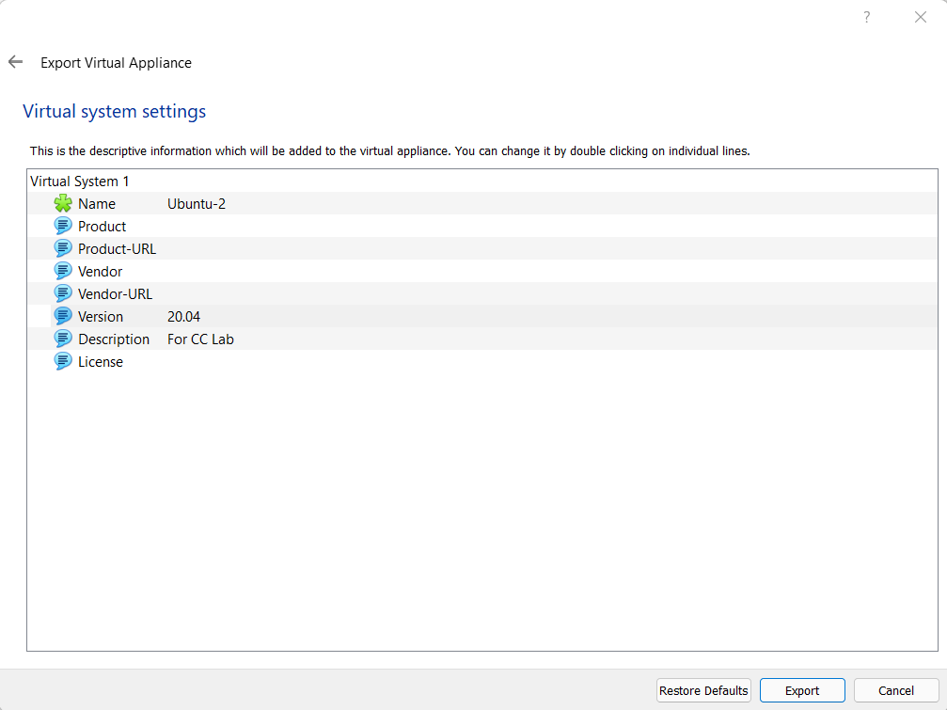

6. Wait for the process to complete

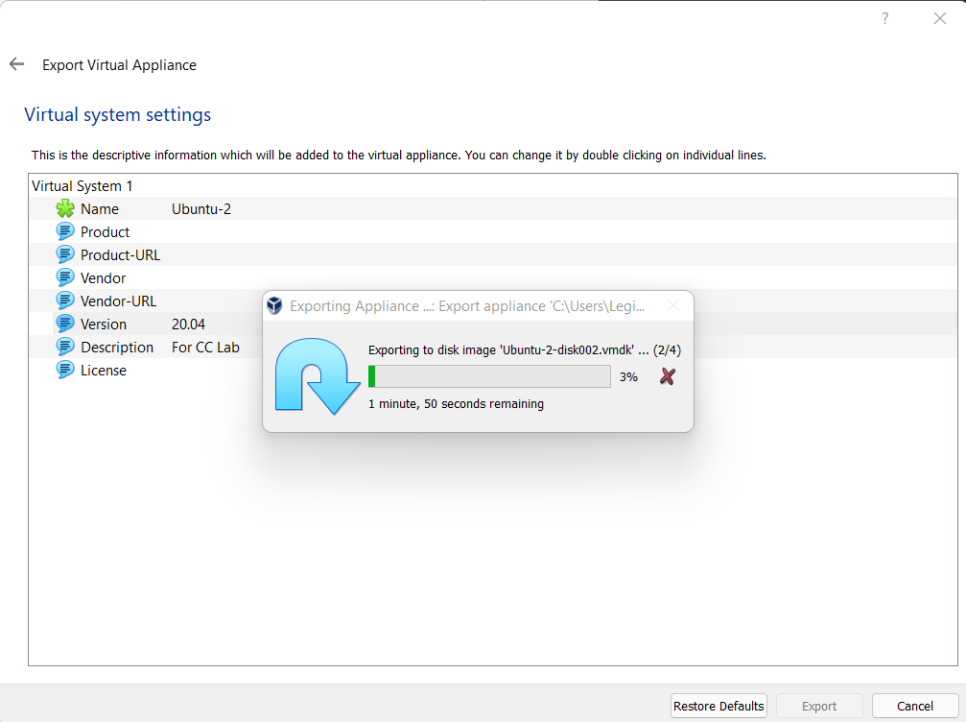

7. Check the Location to see the exported .ova file.

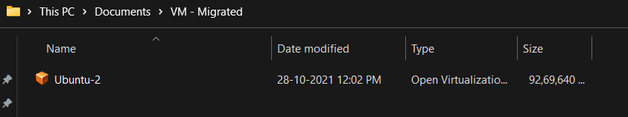

**Importing VirtualBox VM**

1. Start VirtualBox

2. Click File --> Import Appliance

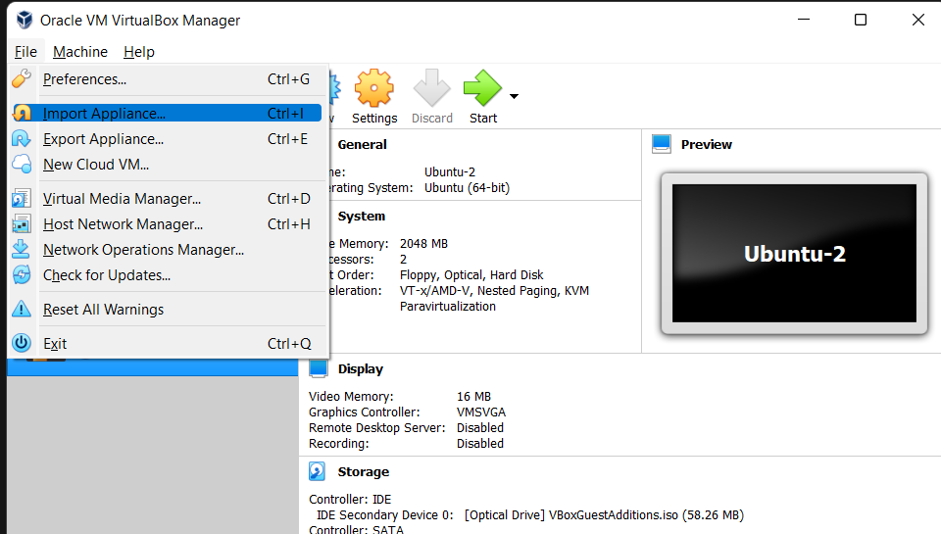

3. Select the OVA file and click next

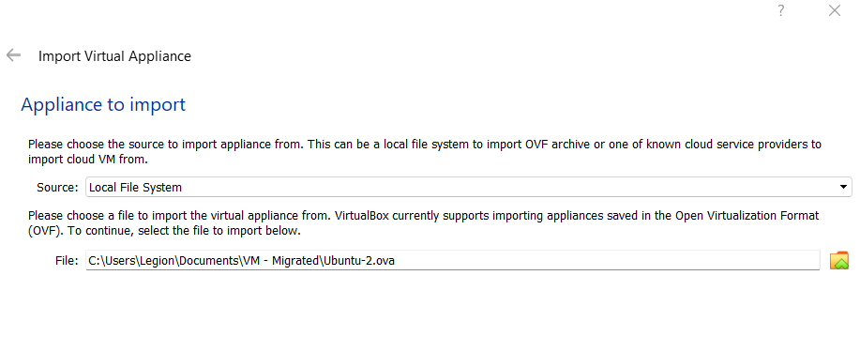4. Leave the default settings and Click import

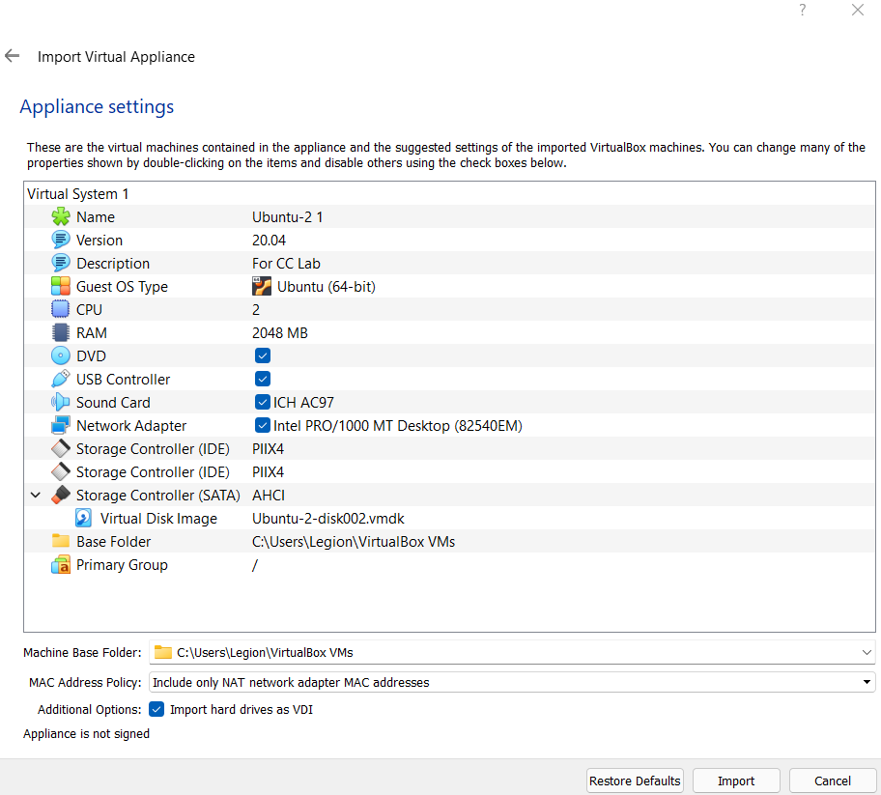

5. Wait for the import to finish

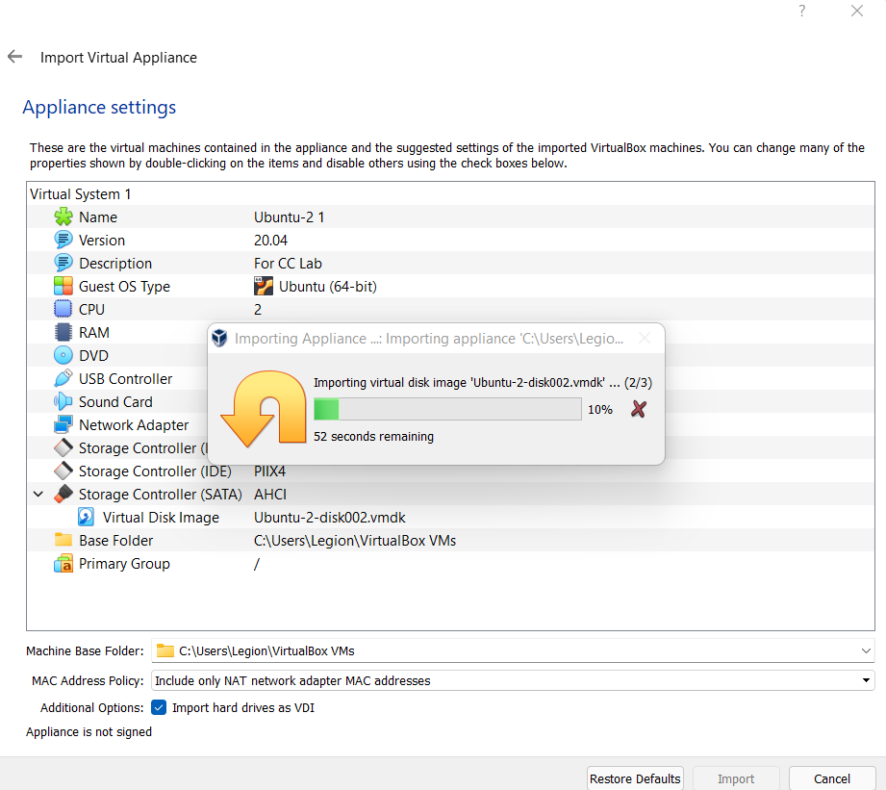

6. The machine will be seen in the VirtualBox homepage

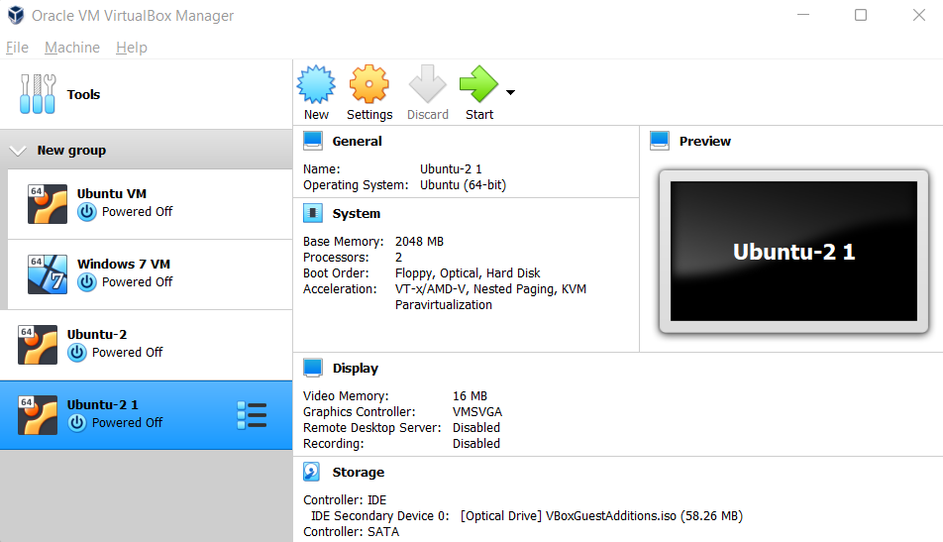

**a static web app in Azure Portal**

1. Click on Create Resource

2. Search for Static Web App

3. Select Static web app

4. Select Create

5. Fill out the details

6.

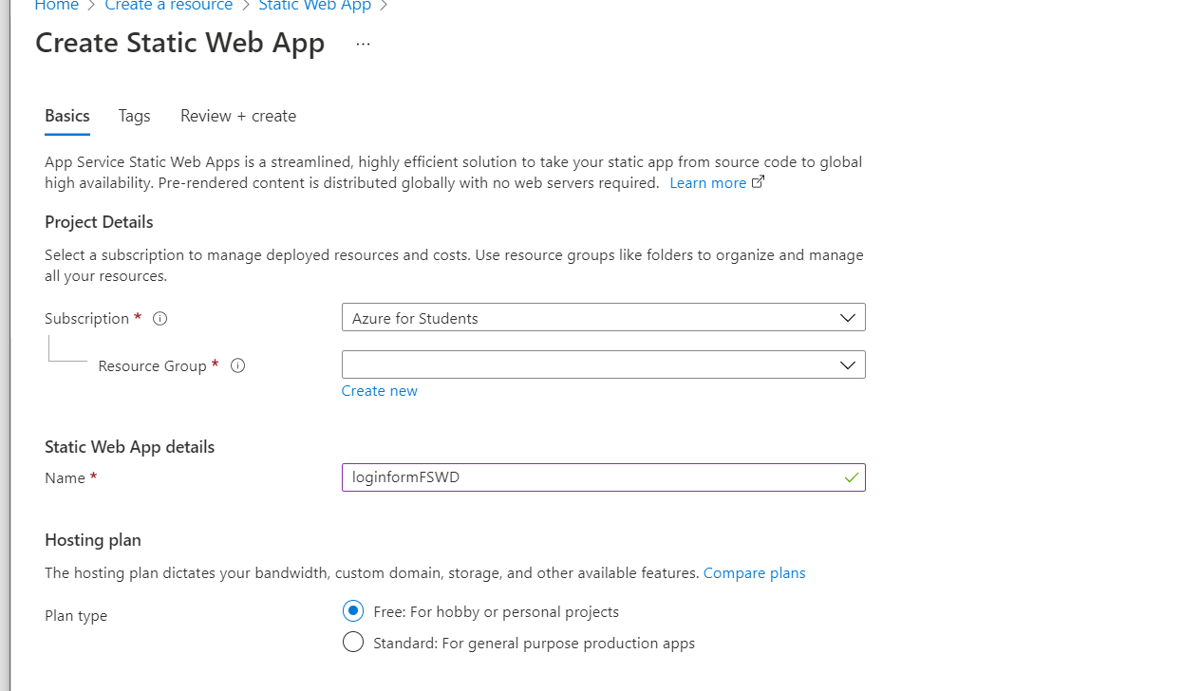

Sign in via GitHub

6. Select organization, Repository and Branch where the HTML file is located

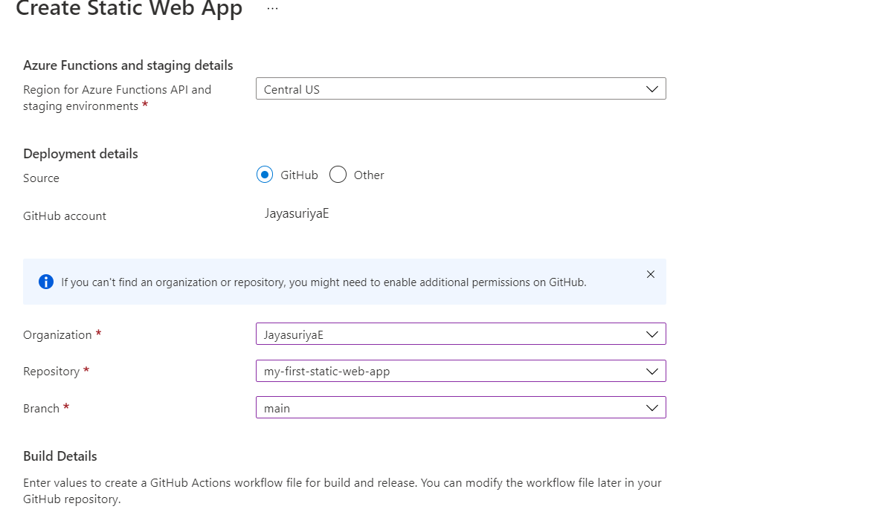

8. Fill in the following Build Details

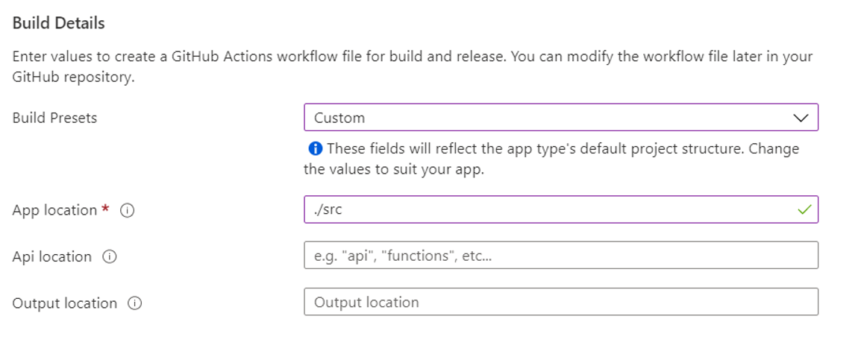

9. Click on Review + Create

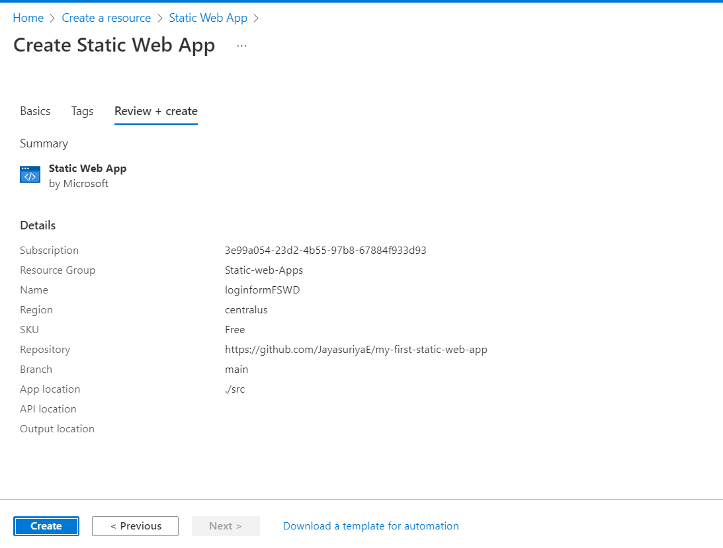

10. Click on Create

11. Click go to resource

12. The URL for the site will be available

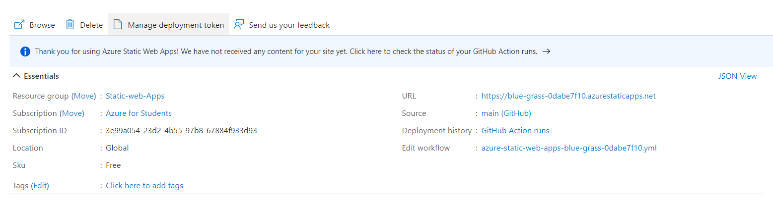

13. Click on the URL to see if it is working

